**Histogram plots for each column in the dataset**

**Correlation matrix plot between the columns in the dataset**

**Scatter plot between the BMI and weight columns (the most correlated ones)**

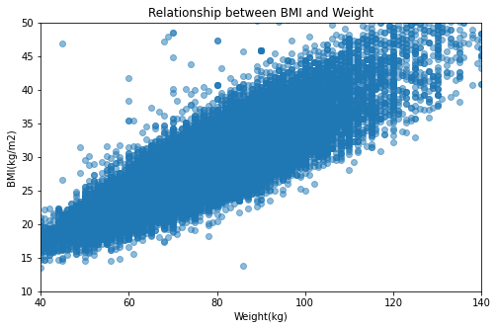

**Target label distribution the dataset**

**Boxplots for numerical features in the dataset for outlier detection**

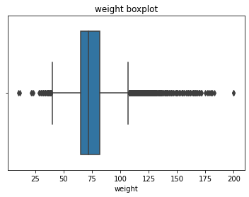

**Scatter plot between features in the dataset for outlier detection**

**Outliers’ detection: 1) visually**

height>=250

weight>=200 and weight<=25

ap_hi>=10000

ap_lo>=5000

age_years<=30

Size of original dataset = 70,000

Size of dataset after outliers’ removal = 69,955 (45 outliers)

**Outliers’ detection: 2) IQR score (interquartile range)**

1. We calculate the 25% quartile of the data (Q1), the 75% quartile of the data (Q3), and the difference between them (IQR = Q3-Q1)
2. We remove any data point x that fits this condition:

x< (Q1 - 1.5 * IQR) and x> (Q3 + 1.5 * IQR)

Size of original dataset = 70,000

Size of dataset after outliers’ removal = 37,602 (32,398 outliers)

**Outliers’ detection: 3) Z-score (interquartile range)**

1. We calculate the z score of the data distribution (z = [data – mean]/standard deviation)
2. Set a threshold = 3 and find the data points that have a z-score < threshold to be considered an outlier

Size of original dataset = 70,000

Size of dataset after outliers’ removal = 55,604 (14,396 outliers)

**Features selection**

**Feature Selection with Univariate Statistical Tests**

* Method 1: Feature Extraction with RFE (Logistic regression)

🡪 Features ranking:

[('ap_hi', 1),

('cholesterol', 1),

('gluc', 1),

('alco', 1),

('active', 1),

('bmi', 1),

('gender', 2),

('smoke', 3),

('height', 4),

('weight', 5),

('age_years', 6),

('ap_lo', 7)]

Get features having features ranking = 1 (best estimated features):

['ap_hi', 'cholesterol', 'gluc', 'alco', 'active', 'bmi']

* Method 2: Features Importance with Extra Trees Classifier

🡪 Features importance:

[('ap_hi', 0.1868844524597645),

('bmi', 0.16711438339373774),

('weight', 0.15461972304489624),

('age_years', 0.14770610031360512),

('height', 0.1459426629263903),

('ap_lo', 0.10923315694269002),

('cholesterol', 0.044139116106184685),

('gluc', 0.01447066508142241),

('gender', 0.009778959534314121),

('active', 0.007701173530480231),

('smoke', 0.006744981215201378),

('alco', 0.005664625451313029)]

Get features having features importance > 0.01 (threshold for best estimated features):

['ap_hi', 'bmi', 'weight', 'age_years', 'height', 'ap_lo', 'cholesterol', 'gluc']

* Method 3: Removing correlated features

🡪 Correlated features with score > 0.7:

[‘bmi’]

Finally, select features that exits in the intersection of the three selected features:

['height', 'weight', 'ap_hi', 'ap_lo', 'cholesterol', 'gluc', 'alco', 'active', 'age_years']